Name: ________________________________________________ Date: _______________________

**Unit #3C Review**

Graph the following equation. Then, write the characteristics for the graph.

1. 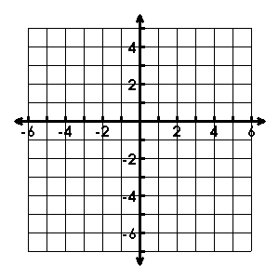

* Vertex: _______________
* Axis of Sym.: __________
* Zeroes: _______________
* Y-int: _________________
* Increase: _____________
* Decrease: ____________
* Vertex: _______________
* Axis of Sym.: __________
* Domain: ______________
* Range: _______________
* Increase: _____________
* Decrease: ____________

1. 

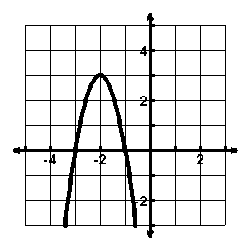

* Describe the transformations:

___________________________

___________________________ ___________________________

* Write the equation:

___________________________

* Roots: _______________

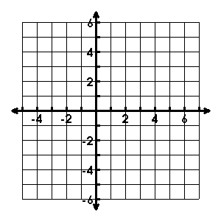

1. Sketch the quadratic function using the given information:



Describe the transformations to the parent function in the given equations.

1. 
2. 

Write the quadratic equation of the graph that has been….

1. shifted down 1 and shrunk by a factor of 
2. reflected over the x-axis and has shifted right 2

Change the equations to standard form.

1. 
2. 

Change the equations to vertex form.

1. 
2. 

An object is projected into the air with a path described by the function  where h is the height above the ground in feet and t is the time in seconds since the object started along the path.

1. Find the time the object changes direction.
2. Find the maximum height of the object.
3. Describe the location of the object at 2.5 seconds.
4. Describe the location of the object at 4.1 seconds.

Use the table of maximum load allowances for various heights of spruce columns.

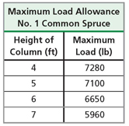

1. Find a quadratic regression equation to model the max

load given height.

1. Use your model to predict the maximum load allowed for

an 8 ft. spruce column.

1. Compare the vertex, y-intercept, and rate of change from x1 = 1 to x2 = 2 for each of the following functions.

|  |  |
| --- | --- |
| **X** | **Y** |
| 0 | -26 |
| 1 | -12 |
| 2 | -2 |
| 3 | 4 |
| 4 | 6 |
| 5 | 4 |
| 6 | -2 |

* 1. 
  3. 